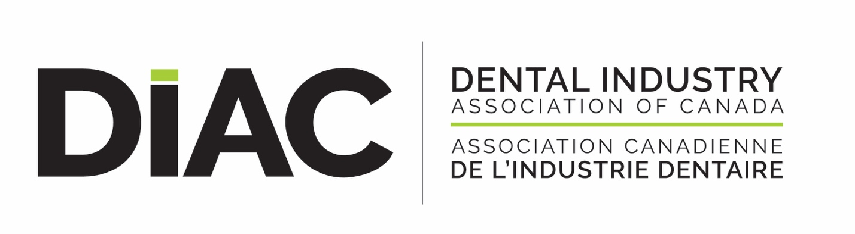

PPE Update: What’s the state of the market right now June 1, 2020?

DIAC has been tracking and reporting on the PPE supply chain since January when China stopped all exports of PPE, February/March when France shut down all exports and into March/April when the US threatened to stop, then severely reduced all exports of PPE from the US.

Since then the shortages of PPE in countries that do not manufacture these products has hit crisis proportion as the demand quickly outstripped supply. Since my last review of the market at the end of April there has been some small changes since then in the supply of PPE in our industry.

N95 - Surgical grade and N95 Commercial grade respirators continue to be a challenge - NIOSH (National Institute for Occupational Safety & Health) approved product are in high demand globally. While manufacturers have increased production dramatically, there continues to be low supply in the traditional Canadian dental supply chain. Some manufacturers are allocating supply based on 2019 sales, foreign governments are controlling export of N95 products and other PPE and with global governments, bidding on and buying up all supply when available, there are very few respirators reaching the regular dental supply chain. Lead times for delivery to the dental supply chain of N95’s are suggested to be towards the end of 2020 to early 2021.

There are a lot of counterfeit products on the market and we caution dentists to be very careful from whom and what you are buying - it has been suggested that the N95 product is the most counterfeited product in the world right now, so “buyer beware”.

ASTM Level 1 - 3 Masks

Manufacturers are continuing to supply although still in limited quantities of masks to the dental community and with more non-traditional manufacturing streaming into markets it is hoped that supply will catch up to demand soon. The issuance of orders from governments and industries, like the airline industry, that require individuals to be masked when not able to maintain social distancing will put an additional strain on supply.

Gowns are in very short supply, but coming on line slowly, although at higher prices due to immediate demand and air transportation costs something that was a manufacturers cost 1.20 - 2.00 per piece before COVID, is now costing $7 - $12 per piece, what was sent by sea transport before COVID at a cost of around $2000 per shipment, is now in high demand being shipped by air at an approximate cost of $60,000 per shipment. But supply is increasing and re-useable fabric gowns are now an alternative and being supplied, a viable and more environmentally friendly alternative to disposable products.

Supply of gloves is a concern and we are watching the supply chain for gloves. Malaysia one of the largest manufacturers of gloves had a 50% reduction in glove production back in early April and were experiencing shortages of raw materials, the impact of which we are now seeing in lead times of 9 - 10 months for re-supply of gloves in some sectors.

Face shields are steadily being supplied, but sell out as quickly as supply comes in. Again, non-traditional manufacturing is gearing up helping to meet the demands of all health care practitioners most face shield demand is being met.

What’s the ray of hope for PPE supply in the Dental Industry?

Based on my discussions with our manufacturers and distributors shortages will be around for another 6 - 9 months for some products, N95’s supply longer. But with local manufacturing starting to gear up, and COVID 19 cases in decline in most provinces as the public follows social distancing rules, wear masks and wash their hands, the curve is continuing to decline and with its decline demand could be easing. In provinces other than Ontario and Quebec new COVID cases are low and the virus slowed.

Canadian manufacturing including those in the dental industry have stepped up and retooled to address the shortages in PPE, it is our hope that this will continue.

GM in Oshawa is now producing 1 million surgical masks per month for the next 10 months.

Canadian manufacturing is coming on line, one of our members just signed a deal with the Federal and their Provincial governments to supply 20 million N95 respirators and 24 million surgical masks per year for the next 10 years starting this summer.

Face shields are available. 3D printing capacity in commercial dental labs have re-focused and are working with Health authorities to produce, masks, face shields, swabs and other products to address the current demand.

At this moment, there are still severe shortages in certain sectors and provinces, demand is still high but the curve is declining.

DIAC is closely monitoring the regulations in each provincial jurisdiction and our members are following the science and guidance that the colleges and associations are recommending for re-opening of dental practices ensuring the safety of patients and practitioners.

How to avoid getting burnt?

An area of great concern to the industry association and the dental community is the high level of counterfeit respirator products entering the market from foreign sources.

Many products are sub-standard and do not meet NIOSH specifications approved as respirators.

At the DIAC offices on an average week we get 3 - 4 of these un-licenced establishments trying to sell us N95’s or equivalents.

N95’s are the most counterfeited product in the world right now, you have to be very very careful when ordering.

Respirators are Class 1 medical devices and distributors of these products need to have a medical device establishment licence to import and sell these products in Canada. You can check the Health Canada MDEL Listing on their website/database to ensure the distributor is licenced.

Some of our manufacturers have on their websites a list of their authorized products for sale in Canada. Check the manufacturers website to ensure you are getting what you paid for.

All manufacturers of N95’s sold in Canada sell through authorized licenced distributors, again check with the manufacturer if you are unsure of the origin of the product or the product itself. They are taking an aggressive stance on counterfeit products. Report to the manufacturer, or report to Health Canada any product that you believe is counterfeit or may not be approved for sales in Canada.

N95 respirators need to fit snugly. Individuals need to be fit tested and instructed on the proper use of the product for it to provide the level of protection it was designed for.

The Centre for Disease Control and Prevention, and Health Canada “Buy and sell” have great guidance documents on product specifications and how to identify counterfeit respirators. These are available on their websites.

Generally, products with ear loops cannot provide an adequate seal and most likely will not be N95 surgical/commercial grade products or equivalents. A NIOSH approved respirator will have on each piece of equipment a NIOSH approval number TC-84A-XXXX, model and lot numbers, filter class and filter efficiency level, brand name or registered trademark and NIOSH name and logo.

If there are no markings on the mask, or no numbers, incorrect spelling and ear loops any one of these shortfalls may indicate that the product is counterfeit.

Buying from DIAC members means you are buying from a licenced establishment who will guarantee product quality, product specifications and have the manufacturers support of the products being sold.

DIAC and our members are focused on finding, and delivery of PPE to our customers. We are working with professional associations, regulators, public health and Health Canada to ensure supply of highest quality PPE to support the re-opening of dental offices across Canada, and look forward to continued discussions, consultations and solutions to meet the current crisis and future demand.

Rhonda Lawson
Executive Director
Dental Industry Association of Canada
June 4, 2020

Resources for Identifying Counterfeit Products:
https://buyandsell.gc.ca/specifications-for-COVID-19-products
Specifications for COVID-19 Products - Buyandsell.gc.ca
buyandsell.gc.ca
Buyandsell.gc.ca is the Government of Canada's open procurement information service to find tender opportunities, pre-qualified suppliers, contract awards and history, events for businesses, contacts, and to learn how to do business with the Government of Canada.
https://www.cdc.gov/niosh/npptl/usernotices/counterfeitResp.html
Counterfeit Respirators / Misrepresentation of NIOSH-Approval | NPPTL | NIOSH | CDC
www.cdc.gov
Counterfeit Respirators / Misrepresentation of NIOSH-Approval
https://www.cdc.gov/niosh/npptl/usernotices/AdditionalTips.html
Additional Tips for Spotting Counterfeit Respirators | NPPTL | NIOSH | CDC
www.cdc.gov
Additional Tips for Spotting Counterfeit Respirators
3M information:

- 3M Canada Technical Bulletin: English - www.3M.ca/Coronavirus French - www.3M.ca/CoronavirusFR
  - Within the document above, there are several links to other documents including the technical bulletin for “Respirators and Surgical Masks: A Comparison”
- Bulletin – Fraudulent Activity and Counterfeit Products
- 3M Medical COVID-19 site: https://www.3m.com/3M/en_US/medical-us/coronavirus/
- 3M Safety COVID-19 site: https://www.3m.com/3M/en_US/worker-health-safety-us/covid19/

